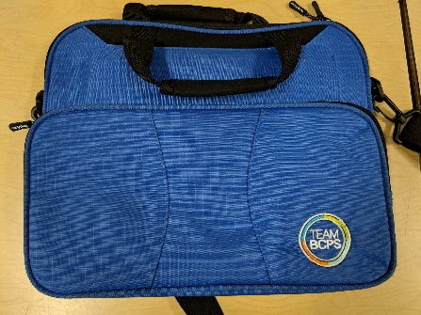
Student Device Bag Washing Instructions
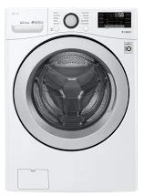Student bags need to be washed by themselves in a washer on a gentle cycle with very little detergent.
The bags do not get put into a dryer. They will need to ‘air’ dry.

- Make sure the bag is completely empty.
- Remove the name label from the bag.
- Remove the strap from the bag.
- The bag should be washed on a Friday evening or Saturday morning so that it has time to dry before Monday morning.
- The bag should be hung up and propped open to dry. Do not dry it in the dryer.
- Put the strap back on the bag.
- Put the name label back in the bag.

